**ASSINGMENT 3 [04/03/2022]**

**1.)Create a SQLite database with a table named as "students" with following fields**

**• first_name as text**

**• last_name ostext**

**• age as number**

**• college as text**

**• branch as text**

**• year as number**

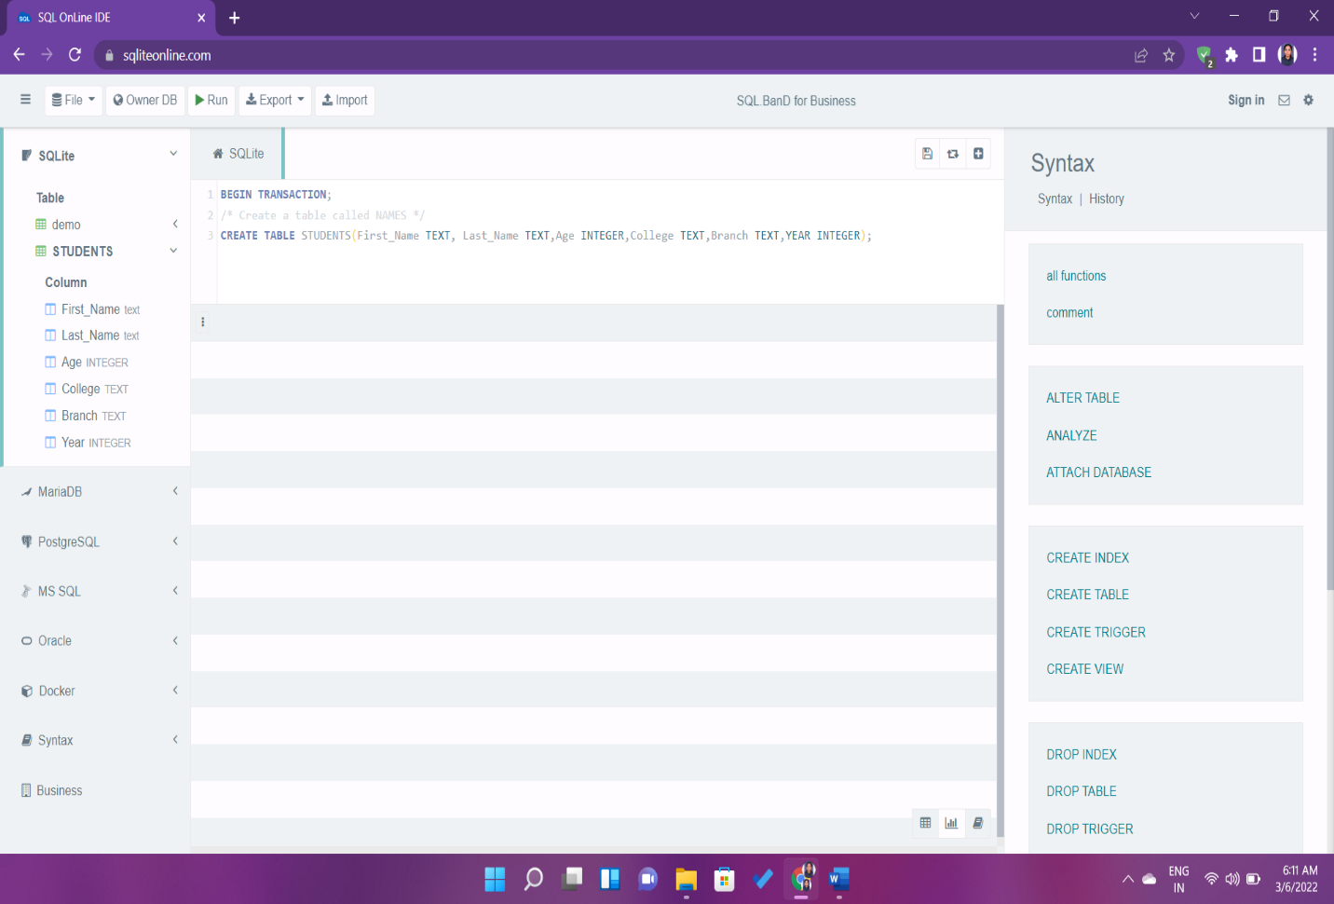

**2.) Insert at least 5 rows**

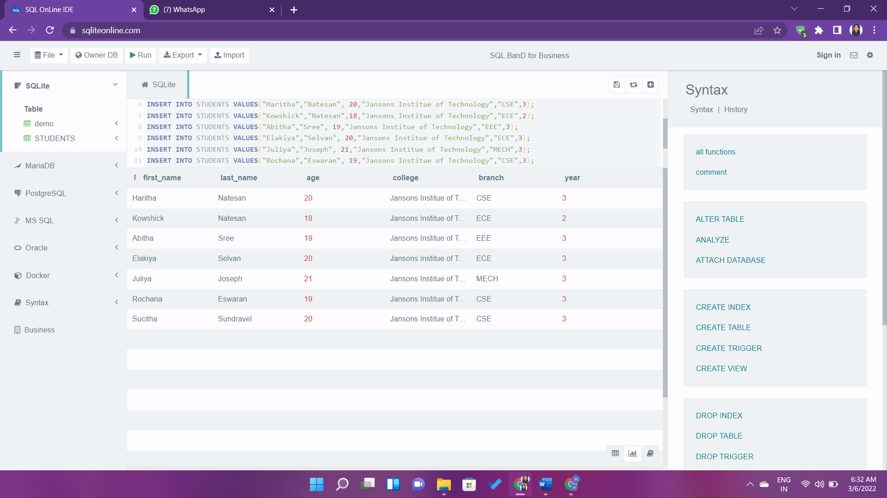

**3.) Update row using first_name and last_name both**

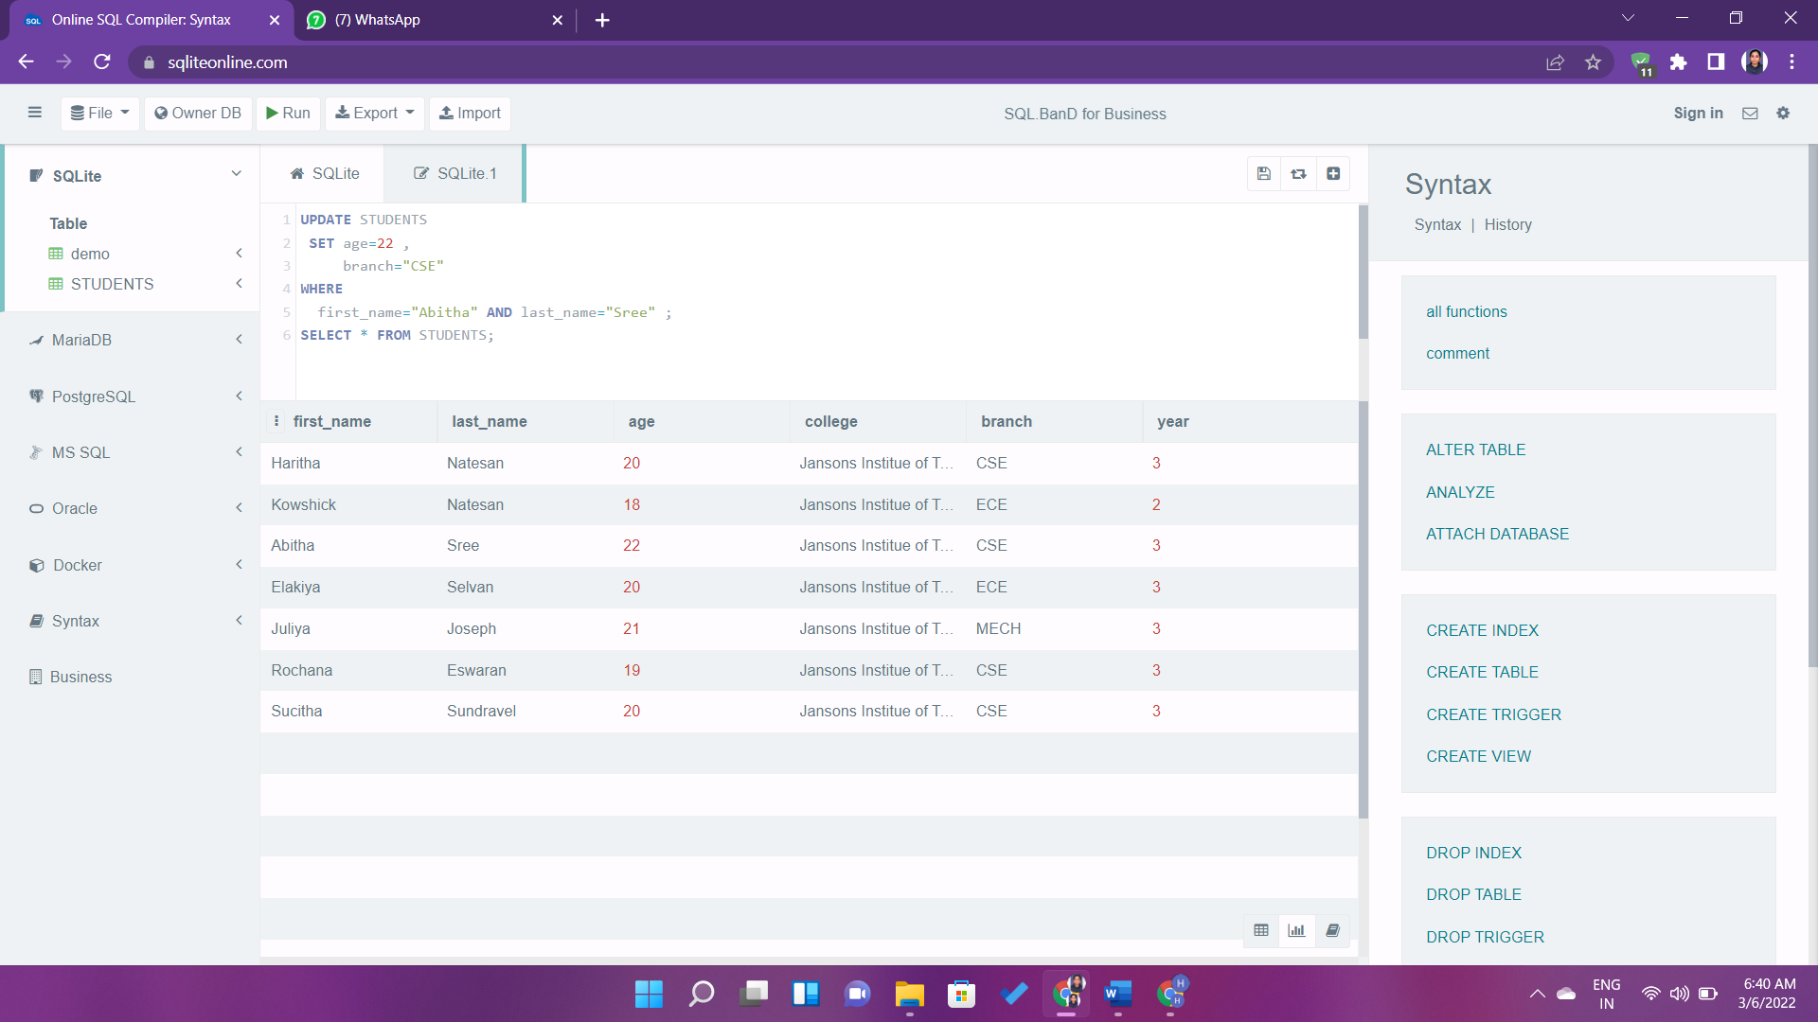

**4.) DELETE LAST ROW**

